**MINISTRY OF ENVIRONMENTAL PROTECTION AND AGRICULTURE**

**OF GEORGIA**

**IRRIGATION AND LAND MARKET DEVELOPMENT PROJECT**

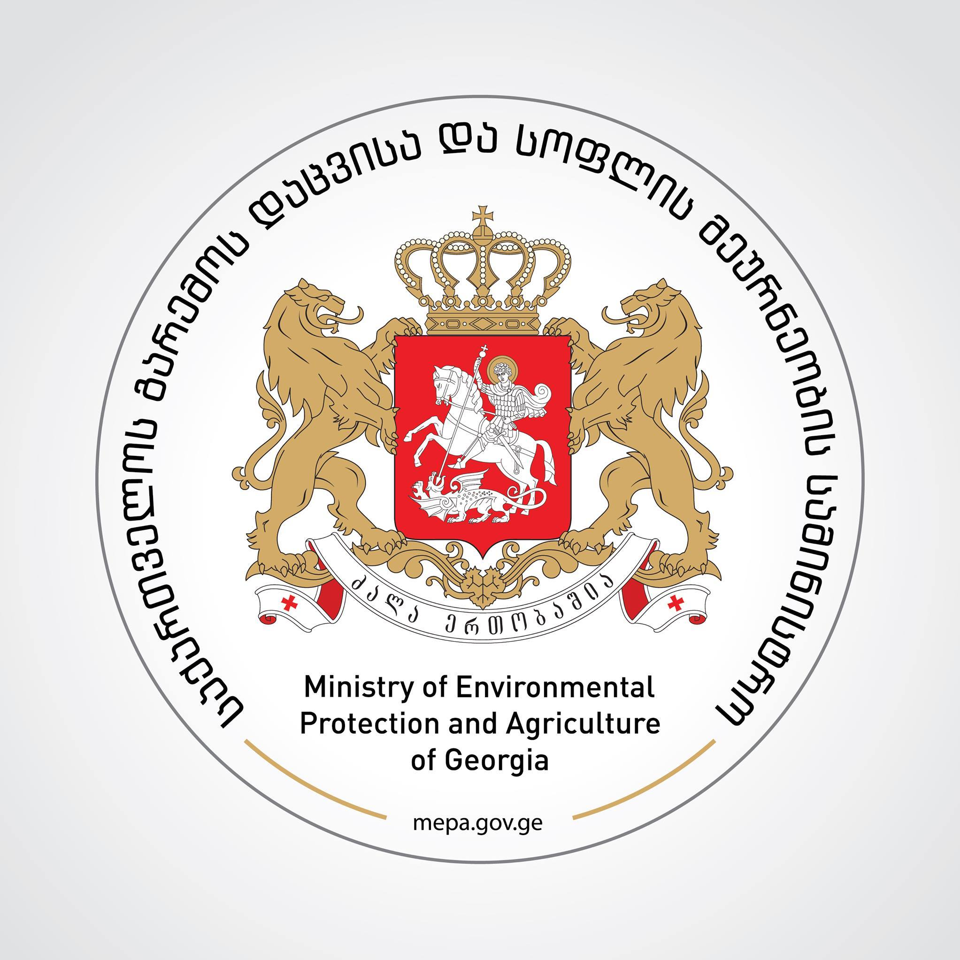

**RECONSTRUCTION OF THE EXISTING SECONDARY, TERTIARY AND QUATERNARY NETWORKS OF ZEDA RU IRRIGATION SYSTEM**

**Environmental and Social Management Plan**

**December 2020**

Due to the challenges faced by Georgia’s agriculture sector, the government of Georgia opted to invest into the restoration of irrigation infrastructure of the country. Th purpose of this decision is to support the development of agriculture infrastructure within the country for increasing efficiency and productivity in farming.

With financial support from the World Bank, the Ministry of Environment Protection and Agriculture of Georgia is rehabilitating and reconstructing secondary, tertiary and quaternary irrigation networks of the selected priority irrigation schemes under the ongoing Irrigation and Land Market Development Project.

Design of rehabilitation works currently is underway. Project environmental and social risks are assessed and found to be **moderate**. It is expected that the Project interventions will not have negative impact outside of the construction sites. The impacts will be localized, temporary and easy to minimize by applying relevant mitigation measures. Environmental and social mitigation measures for the Project activities laid out in the Environmental and Social Management Plan as updated based on roject design documentation December 2020.

The Environmental and Social Management Plan for works on **Zeda-Ru** **Irrigation System** identifies potential environmental and social impact on the rehabilitation and reconstruction of the existing irrigation systems; ensures proper and timely handling of mitigation measures and monitors their progress in order to reduce negative environmental and social impacts during mobilization, construction and operation phases. The document is prepared in accordance of the requirements of World Bank and the legislation of Georgia.

Environmental and Social Management Plan as updated December 2020 for rehabilitation of the **Zeda-Ru** Irrigation Systems can be downloaded from the attached link. For any comments/questions with respect to the document pleasw contact us:

|  |  |
| --- | --- |
| **Description** | **Rehabilitation and Reconstruction of the Zeda Ru irrigation Channel** |
| **Client:** | **Ministry of Environment Protection and Agriculture of Georgia** |
| **To:** | **Sophie Berishvili, Environmental and Social Specialist; Communications Officer** |
| **Address:** | **6 Marshal Gelovani Avenue** |
| **E-mail:** | **Sophiko1@hotmail.com** |
| **Website:** | **www.mepa.gov.ge** |
| **Telephone:** | **+995599270049** |

|  |  |
| --- | --- |
| **Description** | **Rehabilitation and Reconstruction of the Zeda Ru irrigation Channel** |
| **Client:** | **Ministry of Environment Protection and Agriculture of Georgia** |
| **To:** | **Giorgi Kalandadze, Deputy Project Director** |
| **Address:** | **6 Marshal Gelovani Avenue** |
| **E-mail:** | **giorgi.kalandadze@mepa.gov.ge** |
| **Website:** | **www.mepa.gov.ge** |
| **Telephone:** | **+995591518888** |

***ESMP document can be downloaded from the following links:***

***In Georgian:*** <https://drive.google.com/file/d/1jbm3TaTt08c9W16UI7Gpqi_6sBklqEWO/view?usp=sharing>

***In English:*** <https://drive.google.com/file/d/18ML0Peuh9uidiV_395yYmJ-EfvvPfULI/view?usp=sharing>