**MINISTRY OF ENVIRONMENTAL PROTECTION AND AGRICULTURE**

**OF GEORGIA**

**IRRIGATION AND LAND MARKET DEVELOPMENT PROJECT**

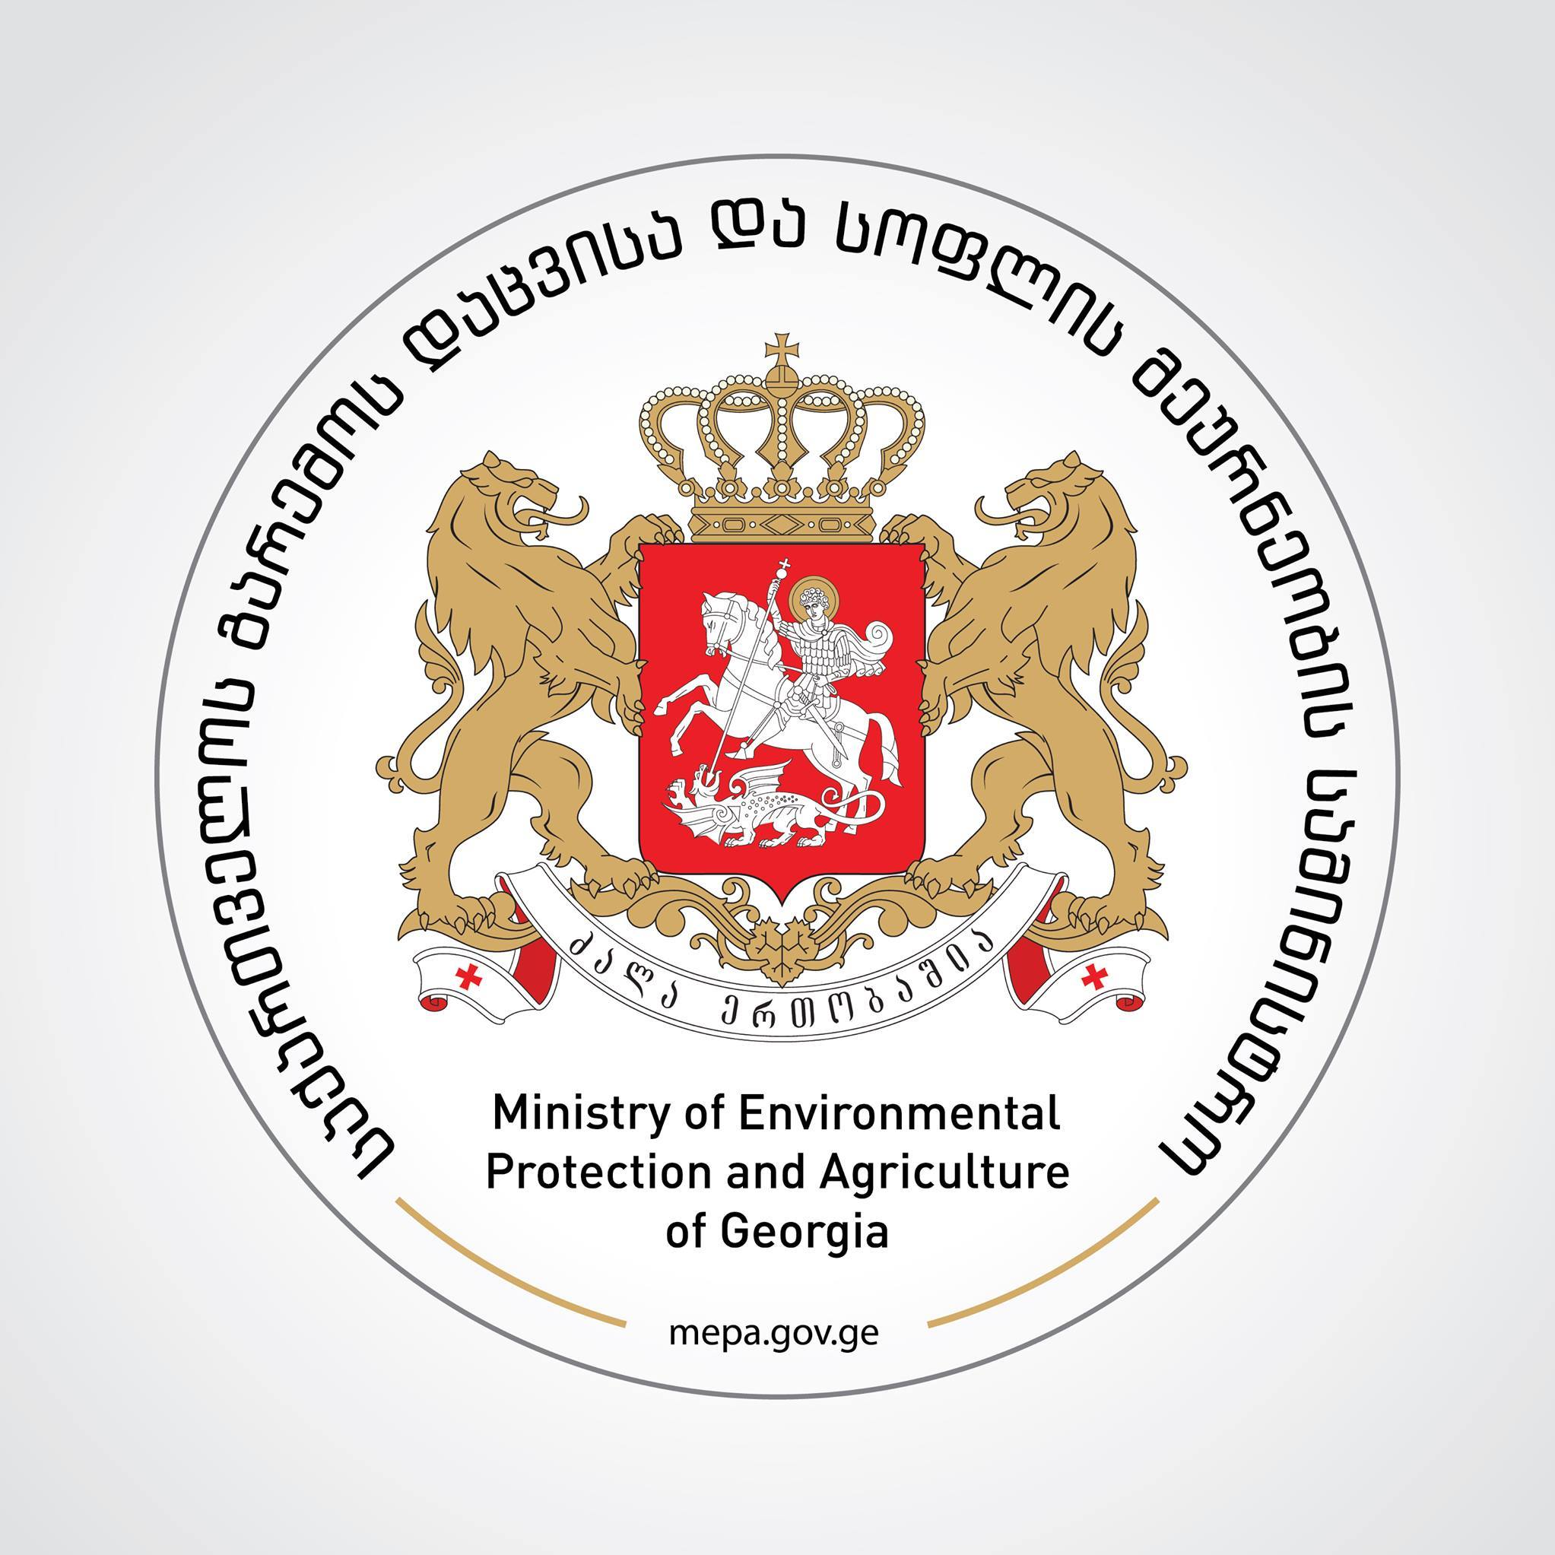

**RECONSTRUCTION OF THE EXISTING SECONDARY, TERTIARY AND QUATERNARY NETWORKS OF ZEDA RU IRRIGATION SYSTEM**

**Environmental and Social Management Plan**

**Public Cosultation Meeting**

**JUNE 26,2020 at 11: 00a.m**

**Gori Municipality Culture House, Small Room address Peace Ave 12/a**

Due to the challenges faced by Georgia’s agriculture sector, the government of Georgia opted to invest into the restoration of irrigation infrastructure of the country. The purpose of this decision is to support the development of agriculture infrastructure within the country for increasing efficiency and productivity in farming.

With financial support from the World Bank, the Ministry of Environment Protection and Agriculture of Georgia is rehabilitating and reconstructing secondary, tertiary and quaternary irrigation networks of the selected priority irrigation schemes under the ongoing Irrigation and Land Market Development Project.

Design of rehabilitation works currently is underway. Project environmental and social risks are assessed and found to be **moderate**. It is expected that the Project interventions will not have negative impact outside of the construction sites. The impacts will be localized, temporary and easy to minimize by applying relevant mitigation measures. Environmental and social mitigation measures for the Project activities laid out in the Environmental and Social Management Plans.

The Environmental and Social Management Plan for works on **Zeda-Ru** irrigation system identifies potential environmental and social impact on the rehabilitation and reconstruction of the existing irrigation systems; ensures proper and timely handling of mitigation measures and monitor their progress in order to reduce negative environmental and social impacts during mobilization, construction and operation phases. The document is prepared in accordance of the requirements of World Bank and the legislation of Georgia.

Environmental and Social Management Plan for works on **Zeda-Ru**irrigation systems can be downloaded from the attached link. Public consultation meeting will be conducted in Gori Municipalty on June 26 at 11:00 am at the address **Culture House, Small Room address Peace Ave 12/a.**

Participants will be required to wear face masks during the session.

|  |  |
| --- | --- |
| **Description** | **Rehabilitation and Reconstruction of the Zeda Ru irrigation Channel** |
| **Client:** | **Ministry of Environment Protection and Agriculture of Georgia** |
| **To:** | **Sophie Berishvili, Environmental and Social Specialist; Communications Officer** |
| **Address:** | **6 Marshal Gelovani Avenue** |
| **E-mail:** | **Sophiko1@hotmail.com** |
| **Website:** | **www.mepa.gov.ge** |
| **Telephone:** | **+599270049** |
| **Description** | **Rehabilitation and Reconstruction of the Zeda Ru irrigation Channel** |
| **Client:** | **Ministry of Environment Protection and Agriculture of Georgia** |
| **To:** | **Giorgi Kalandadze, Deputy Project Director** |
| **Address:** | **6 Marshal Gelovani Avenue** |
| **E-mail:** | **g.kalandadze@meopa.gov.ge** |
| **Website:** | **www.mepa.gov.ge** |
| **Telephone:** | **+591518888** |

***ESMP document can be downloaded from the following link:***

***http://ag.ge/Ge/Announcements/21904***